**3.1 Basic Concept**

The t-test is a test in statistics that is used for testing hypotheses regarding the mean of a small sample taken population when the standard deviation of the population is not known. The t-test is used to determine if there is a significant difference between the means of two groups. The t-test is used for hypothesis testing to determine whether a process has an effect on both samples or if the groups are different from each other. Basically, the t-test allows the comparison of the mean of two sets of data and the determination if the two sets are derived from the same population. After the null and alternative hypotheses are established, t-test formulas are used to calculate values that are then compared with standard values. Based on the comparison, the [null hypothesis](https://microbenotes.com/null-and-alternative-hypothesis/) is either rejected or accepted. The T-test is similar to other tests like the z-test and f-test except that t-test is usually performed in cases where the sample size is 30.

The t-test is a test in statistics that is used for testing hypotheses regarding the mean of a small sample taken population when the standard deviation of the population is not known.

* The t-test is used to determine if there is a significant difference between the means of two groups.
* The t-test is used for hypothesis testing to determine whether a process has an effect on both samples or if the groups are different from each other.
* Basically, the t-test allows the comparison of the mean of two sets of data and the determination if the two sets are derived from the same population.
* After the null and alternative hypotheses are established, t-test formulas are used to calculate values that are then compared with standard values.
* Based on the comparison, the [null hypothesis](https://microbenotes.com/null-and-alternative-hypothesis/) is either rejected or accepted.
* The T-test is similar to other tests like the z-test and f-test except that t-test is usually performed in cases where the sample size is small (n≤30).

**3.2 t-test formula**

## One sample t-test formula

The one sample t-test formula is used to compare the mean of one sample to a known standard mean. The one-sample t-test formula can be written as follow:

$$t=\frac{m-μ}{s/{\sqrt{n}}}$$

Where,

* m is the sample mean
* n is the sample size
* s is the sample standard deviation with n−1 degrees of freedom
* μ is the theoretical mean

The p-value, corresponding to the absolute value of the t-test statistics (|t|), is computed for the degrees of freedom (df): df = n - 1.

## Two sample t-test formula

We perform a Two-Sample t-test using following formula

$$t=\frac{\left({\overline{x}}_{1}-{\overline{x}}_{2}\right)-(μ_{1}-μ_{2})}{\sqrt{\frac{s_{1}^{2}}{n_{1}}+\frac{s_{2}^{2}}{n_{2}}}}$$

**Where**

* ${\overline{x}}_{1}$ is the sample mean for group one
* ${\overline{x}}_{2}$ is the sample mean for group two
* $(μ_{1}-μ_{2})$ is difference between Population Mean
* $n_{1}$ is the sample size for group one
* $n_{2}$ is the sample size for group two
* $s_{1}$ is standard deviation for group one
* $s_{2}$ is standard deviation for group two

**Degree of freedom**

$$d.o.f.=\frac{{(\frac{s_{1}^{2}}{n_{1}}+\frac{s_{2}^{2}}{n_{2}})}^{2}}{(\frac{s_{1}^{4}}{n_{1}^{2}(n_{1}-1)}+\frac{s_{2}^{4}}{n_{2}^{2}(n_{2}-1)})}$$

**3.3 Step used in t test**

#### Step 1: Assumptions

For the one-sample t test, we use individual scores; for the paired-samples t test, we use **difference scores**. The comparison distribution is a distribution of mean

The comparison distribution will be a distribution of mean differences. The hypothesis test will be a paired-samples t test because we have two samples, and all participants are in both samples.

#### Step 2: State the null and alternative hypotheses.

Remember, hypotheses are always about populations, not about our specific samples.

Null hypothesis:

Alternative hypothesis:

#### Step 3: Determine the characteristics of the comparison distribution

With the paired-samples t test, we have a sample of difference scores. According to the null hypothesis, there is no difference; that is, the mean difference score is 0. So the mean of the comparison distribution is always 0, as long as the null hypothesis posits no difference.

#### Step 4: Determine the significance level

The exercise already did that for us.

alpha = 0.05

#### Step 5: Calculate Test Statistic

This step is identical to that for the single- sample t test.

#### Step 6 : Conclude

**3.4 Outline of proposed appoacrch**

Check all assumption n required for T-Test

All assumption Correct

No

State the null and alternative hypotheses

Yes

Determine the characteristics of the comparison distribution

Determine the significance level

Calculate Test Statistic

Conclude

Figure 3.1 outline of proposed work

**3.5 Illustrate with example**

Score of Boys and Girls out of 700 in online examination mains

Table 3.1 Number of Student Selected for JEE Exam form 10 different Center

|  |  |  |
| --- | --- | --- |
| S NO | Girls (xi) | Boys (yi) |
| 1 | 587 | 626 |
| 2 | 602 | 643 |
| 3 | 627 | 647 |
| 4 | 610 | 634 |
| 5 | 619 | 630 |
| 6 | 622 | 649 |
| 7 | 605 | 625 |
| 8 | 608 | 623 |
| 9 | 596 | 617 |
| 10 | 592 | 607 |

Table 3.2 Calculating Mean Score for Girls

|  |  |  |  |
| --- | --- | --- | --- |
| S NO | Girls ${(x}_{i})$ | $$(x_{i}-\overline{x)}$$ | $${(x_{i}-\overline{x})}^{2}$$ |
| 1 | 587 | -19.8 | 392 |
| 2 | 602 | -4.8 | 23.04 |
| 3 | 627 | 20.2 | 408.04 |
| 4 | 610 | 3.2 | 10.24 |
| 5 | 619 | 12.2 | 148.84 |
| 6 | 622 | 15.2 | 231.04 |
| 7 | 605 | -1.8 | 3.312 |
| 8 | 608 | 1.2 | 1.44 |
| 9 | 596 | 10.8 | 116.64 |
| 10 | 592 | -14.8 | 219.04 |
|  | 6068 |  | 1553.63 |

* Mean Score for Girls is 606.8 (609)

$$σ_{1}=\sqrt{\frac{{\sum{(x_{i}-μ)}}^{2}}{N}}$$

where

σ= population standard deviation

µ= [the population mean](https://www.google.com/search?sxsrf=AOaemvIExWm0u2MdDs574FL5KadGbR7vtA:1634028851878&q=Mean&stick=H4sIAAAAAAAAAOPgE-LQz9U3MCs3MlICs0zKCky0tLKTrfRTU0qTE0sy8_P00_KLcktzEq2gtEJmbmJ6qkJiXnF5atEjRmNugZc_7glLaU1ac_IaowoXV3BGfrlrXklmSaWQGBcblMUjxcUFt4BnESuLb2piHgBE6iKyfwAAAA&sa=X&ved=2ahUKEwjR05Lqv8TzAhVYOSsKHXQeDh4Q24YFegQIFBAC)

$x_{i}$ = each value from the population

*N*=the size of the population

$$σ_{1}=\sqrt{\frac{1553.63}{10}}$$

$$σ_{1}=\sqrt{155.36}$$

$σ_{1}=12.46$

Table 3.3 Calculating Mean Score for Girls

|  |  |  |  |
| --- | --- | --- | --- |
| S NO | Boys ${(y}_{i})$ | $(y_{i}-\overline{y}$) | $${(y_{i}-\overline{y})}^{2}$$ |
| 1 | 626 | -4 | 16 |
| 2 | 643 | 13 | 169 |
| 3 | 647 | 17 | 289 |
| 4 | 634 | 4 | 16 |
| 5 | 630 | 0 | 0 |
| 6 | 649 | 19 | 361 |
| 7 | 625 | -5 | 25 |
| 8 | 623 | -7 | 49 |
| 9 | 617 | -13 | 169 |
| 10 | 607 | -23 | 529 |
|  | 6301 |  | 1623 |

* Mean Score for Boys is 630.1(630)

$$σ_{2}=\sqrt{\frac{{\sum{(x_{i}-μ)}}^{2}}{N}}$$

where

σ= population standard deviation

µ= [the population mean](https://www.google.com/search?sxsrf=AOaemvIExWm0u2MdDs574FL5KadGbR7vtA:1634028851878&q=Mean&stick=H4sIAAAAAAAAAOPgE-LQz9U3MCs3MlICs0zKCky0tLKTrfRTU0qTE0sy8_P00_KLcktzEq2gtEJmbmJ6qkJiXnF5atEjRmNugZc_7glLaU1ac_IaowoXV3BGfrlrXklmSaWQGBcblMUjxcUFt4BnESuLb2piHgBE6iKyfwAAAA&sa=X&ved=2ahUKEwjR05Lqv8TzAhVYOSsKHXQeDh4Q24YFegQIFBAC)

$x_{i}$ = each value from the population

*N*=the size of the population

$$σ_{2}=\sqrt{\frac{1623}{10}}$$

$$σ_{2}=\sqrt{162.3}$$

$σ_{1}=12.73$

Now calculating values for t statistics

$t=\frac{\left({\overline{x}}_{1}-{\overline{x}}_{2}\right)-(μ_{1}-μ_{2})}{\sqrt{\frac{s_{1}^{2}}{n_{1}}+\frac{s_{2}^{2}}{n_{2}}}}$

$$t=\frac{\left(630.1-606.8\right)-(μ_{1}-μ_{2})}{\sqrt{\frac{{(12.73)}^{2}}{10}+\frac{{(12.46)}^{2}}{n_{2}}}}$$

$$t=\frac{\left(630.1-606.8\right)-(15)}{\sqrt{\frac{{(12.73)}^{2}}{10}+\frac{{(12.46)}^{2}}{n_{2}}}}$$

$$t=\frac{\left(630.1-606.8\right)-(15)}{\sqrt{\frac{162}{10}+\frac{156.9}{10}}}$$

$$t=\frac{23.3-15}{\sqrt{\frac{162}{10}+\frac{156.9}{10}}}$$

$$t=\frac{8.3}{\sqrt{16.2+15.69}}$$

$$t=\frac{8.3}{\sqrt{16.2+15.69}}$$

$$t=\frac{8.3}{\sqrt{31.89}}$$

$$t=\frac{8.3}{5.64}$$

$$t=1.471$$

Now compare t statistics value with standard t value to draw conclusion

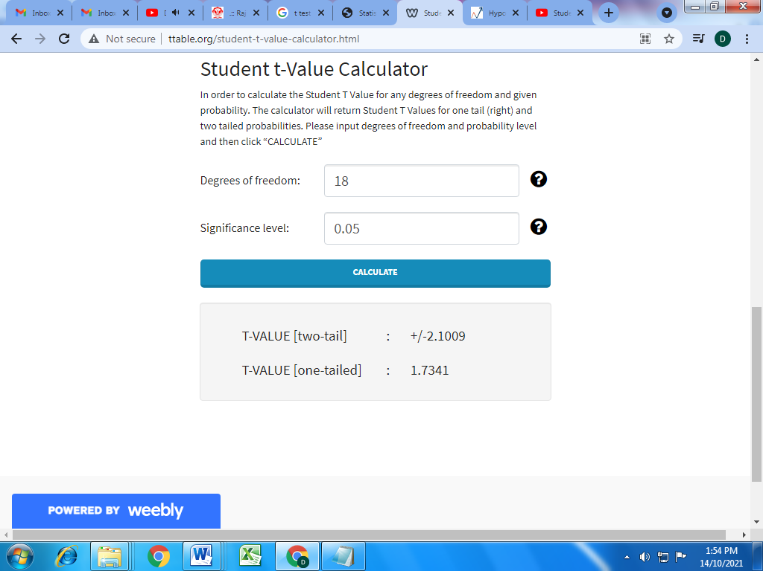

Figure 3.2 standard t value calculator